Student worksheet

Activity 1: The nitration of methyl benzoate – to form methyl 3-nitrobenzoate
Objective
- Be able to perform the controlled nitration of a benzene derivative.
- Be able to manipulate materials and equipment with care and precision.
Equipment/materials
- 8 cm³ of concentrated sulfuric acid (corrosive)
- 5 cm³ of concentrated nitric acid (corrosive and oxidising)
- 3 cm³ of methyl benzoate (harmful by inhalation)
- 10 cm³ methanol (highly flammable and harmful)
- 50 cm³ round-bottomed flask with two ground glass joints (Quickfit)
- Boiling tube
- 50 cm³ dropping funnel (Quickfit)
- Two thermometers (-10 to 110 °C)
- Two 250 cm³ beakers (for ice baths)
- 100 cm³ beaker
- Four 10 cm³ measuring cylinders
- Spatula
- Stand, clamp and boss
- Access to vacuum filtration, a balance, melting point apparatus, boiling water and ice

Safety
- Perform the experiment in a well-ventilated room.
- Wear a lab coat and tie long hair back.
- Wear safety goggles when handling concentrated acids.
- Wear chemical-resistant gloves when handling concentrated acids.

Corrosive Oxidising

Harmful Flammable
Procedure
- Clamp a round-bottomed or pear shaped flask into an ice bath. See Figure 1.
- Pour 5.0 cm³ of concentrated sulfuric acid into the flask and cool it to 5 °C. Slowly add 3.0 cm³ of methyl benzoate to the sulfuric acid, keeping the temperature at 5 °C.
- Into a boiling tube, also cooled by an ice bath, pour 3.0 cm³ of concentrated nitric acid and 3.0 cm³ of concentrated sulfuric acid. Mix and cool the solution to 5 °C. This is your nitrating mixture.
- Add, drop-wise, the nitrating mixture to the solution containing the ester. Maintain the temperature between 20 and 25 °C.
- When all the nitrating mixture has been added, leave the mixture for about 10 minutes at room temperature.
- Pour the solution into a small beaker half-filled with crushed ice. It might be convenient to stop at this point until next lesson.
- Filter the solid from the solution under reduced pressure and wash with a minimum of cooled methanol.
- Recrystallise the nitrated ester with methanol. Dry it at room temperature and find the mass of your product and record it.
- Determine and record the melting point of the methyl 3-nitrobenzoate.
Analysis of results
C₆H₅COOCH₃ + HNO₃ → O₂NC₆H₄COOCH₃ + H₂O
- Calculate the mass of methyl benzoate used in the reaction.
- Use the mass of methyl benzoate to calculate the expected yield of methyl 3-nitrobenzoate.
- Use the actual yield and the expected yield to calculate the percentage yield of methyl 3-nitrobenzoate.

From the examiner
- Demonstrate skilful and safe practical techniques.
- Record measurements to an appropriate precision.
- Consider the accuracy of your data before deciding on the number of significant figures for the answer.
Data/diagram
- H = 1.0, C = 12.0, N = 14.0 and O = 16.0.
- The density of methyl benzoate is 1.09 g cm^{–3}.

Figure 1
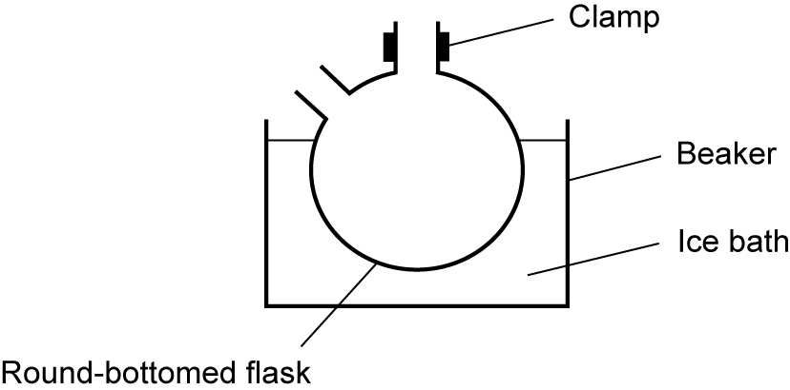

.
Questions
- Give the equation for the reaction that occurs between nitric acid and sulfuric acid in the nitrating mixture.
- Why is it necessary to maintain the temperature between 20 and 25 °C in step 5?
- Name the type of mechanism that occurs in this reaction and show the steps of the mechanism. Show all curly arrows and the intermediate that is formed during the reaction.
- Sulfuric acid acts as a catalyst in this reaction. Using appropriate equations, show why it is considered to be a catalyst.
- Substitution occurs at carbon-3 in the benzene ring; what effect does the ester group have upon the benzene ring and why?

