75
Student worksheet

Activity 6: Hydrolysis of an ester – the hydrolysis of methyl benzoate to produce benzoic acid

Objective
- Be able to manipulate materials and equipment with care and precision.
- Be able to hydrolyse an ester and produce a good yield of pure product.

Equipment/materials
- 3 cm³ methyl benzoate (harmful by inhalation)
- 10 cm³ 2 mol dm^{–3} sodium hydroxide (corrosive)
- 10 cm³ ethanol (highly flammable)
- 20 cm³ 2 mol dm^{–3} hydrochloric acid (irritant)
- Methyl orange indicator
- 50 cm³ round-bottomed flask (Quickfit)
- Water-cooled condenser (Quickfit) and rubber tubing
- Four 10 cm³ measuring cylinders
- Anti-bumping granules
- Bunsen burner and safety mat
- Stand, clamp and boss
- Two 100 cm³ beakers
- Stirring rod and spatula
- Access to vacuum filtration, a balance, melting point apparatus and boiling water
- Dropping pipettes

Safety
- Perform the experiment in a well-ventilated room
- Wear a lab coat and nitrile disposable gloves, tie long hair back.
- Wear goggles.
- Benzoic acid is harmful.


Harmful/Irritant
Flammable
Corrosive

Procedure
- Measure 3.0 cm³ of methyl benzoate and pour it into the 50 cm³ round-bottomed flask. Add 10 cm³ of the 2 mol dm^{–3} sodium hydroxide solution and 10 cm³ of ethanol to the flask.
- Add a few anti-bumping granules to the flask and then place the water-cooled condenser into the flask ready for refluxing.
- Heat the flask gently and slowly bring the contents to the boil. Reflux for 20 minutes.
- Allow the contents of the flask to cool with the condenser still in place. When cool, remove the condenser from the flask and decant the contents of the flask into the 100 cm³ beaker.
- Add 4–5 drops of methyl orange indicator and stir the solution. Acidify with 1 cm³ portions of hydrochloric acid solution stirring after each addition – this process should use less than 20 cm³ of HCl(aq). Filter the solid product under reduced pressure.
- Recrystallise the product (benzoic acid) using a minimum volume of boiling water. Filter the purified benzoic acid under reduced pressure and allow it to dry in the air.
- When dry, weigh the benzoic acid and record its mass.
- Take some of the dry sample and find the melting point of the benzoic acid. Record its melting point.

Data/diagram
- H = 1.0, C = 12.0 and O = 16.0
- Density of methyl benzoate is 1.09 g cm^{–3}.

Figure 6
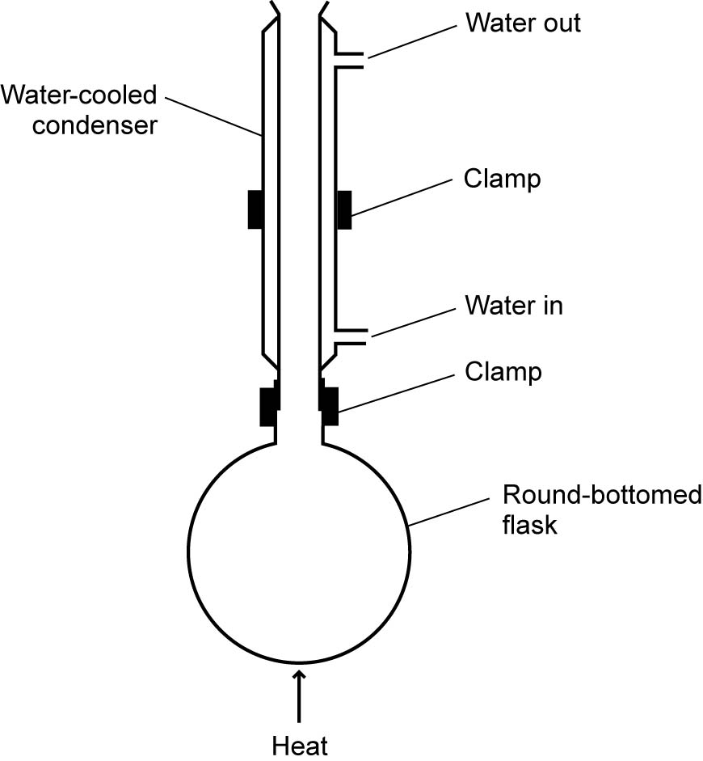

Analysis of results
C₆H₅COOCH₃ + OH– → C₆H₅COO– + CH₃OH
C₆H₅COO– + H⁺ → C₆H₅COOH
- Record your observations in an appropriate format.
- Calculate the mass of the 3 cm³ sample of methyl benzoate used.
- Use the given equations and your yield of benzoic acid to calculate the percentage yield.

From the examiner
- Demonstrate skilful and safe practical techniques.
- Record measurements to an appropriate precision.
- Consider the accuracy of your data before deciding on the number of significant figures for the answer.

Questions
- The solution is acidified in step 5, why?
- Explain why ethanoic acid is water soluble but benzoic acid is not soluble in cold water.
- Suggest what might be the most significant procedural error and suggest a modification for it.
- Give two reasons why your percentage yield is less than 100%.
- A suggested mechanism for the hydrolysis of the ester involves the hydroxide ion as a nucleophile. Complete the mechanism below, putting dipoles and curly arrows where necessary.

