Student worksheet

Activity 7: Reactions of ethanoic anhydride and the synthesis of aspirin (acetylsalicylic acid)
Objective
- Be able to perform and explain the reactions of acid anhydrides.
- Be able to synthesise aspirin from 2-hydroxybenzoic acid.
Equipment/materials
- 10 cm³ ethanoic anhydride (corrosive)
- 10 cm³ ethanol (highly flammable)
- 5 cm³ 0.5 mol dm^{–3} sodium carbonate solution (low hazard)
- Phenol (corrosive and toxic)
- 1 cm³ 0.5 mol dm^{–3} sodium hydroxide solution (corrosive)
- Distilled/deionised water
- 2 g 2-hydroxybenzoic acid (harmful)
- 1 cm³ concentrated sulfuric acid (corrosive)
- Three test tubes
- Dropping pipettes
- Pear-shaped flask
- 250 cm³ beaker
- Ice
- Bunsen burner, tripod, gauze and safety mat
- Access to vacuum filtration, a balance, melting point apparatus
- Stand, clamp and boss
- Spatula
- Five 10 cm³ measuring cylinders
- Universal indicator paper or solution

Safety
- Perform the experiment in a well-ventilated room.
- Wear a lab coat and tie long hair back.
- Wear safety goggles.
- Wear nitrile disposable gloves when handling phenol.


Corrosive Harmful
Flammable Toxic

Procedure
- Add 10 drops of ethanoic anhydride to 1 cm³ of distilled/deionised water. Note the vigour of the reaction and test the pH of the solution with universal indicator paper or solution.
- Add 10 drops of ethanoic anhydride to 1 cm³ of ethanol. Neutralise the excess acid with 1 cm³ of sodium carbonate solution. Note the smell of the product.
- Dissolve a few crystals of phenol in 1 cm³ of sodium hydroxide. Add 10 drops of ethanoic anhydride to the solution. Record your observations. (Take great care when handling phenol. It can cause nasty burns.)
- Weigh 2.0 g of 2-hydroxybenzoic acid and place it in a pear-shaped flask. Clamp the flask in a beaker of water.
- Add 5.0 cm³ of ethanoic anhydride to the 2-hydroxybenzoic acid and five drops of concentrated sulfuric acid.
- Bring the water to the boil and heat the mixture in the flask for a further 10 minutes.
- Remove the flask from the boiling water and add 10 cm³ of crushed ice and distilled/deionised water to break down any unreacted ethanoic anhydride.
- Crystals of aspirin should form as the solution is chilled in an ice bath.
- Filter the crystals under reduced pressure. Wash the crystals with a minimum volume of iced water.
- Recrystallise the aspirin in the minimum volume of a mixture of ethanol to water (1:3).
- Filter and dry. Find the mass of the pure crystals and their melting point.
Analysis of results
- What does the pH in step 1 tell you about the product of the reaction?
- Write an equation for the reaction between ethanoic anhydride and water.
- What does the product in step 2 smell like?
- Name this product and give an equation for its formation.
- Name the product formed in step 3 and give an equation for its formation.

From the examiner
- Make and record valid observations.
- Organise your results suitably.
- Demonstrate skilful and safe practical techniques.

Data/diagram
- H = 1.0, C = 12.0 and O = 16.0
- Refer to the OCR data sheet of Chemistry for IR and NMR data.

Figure 7
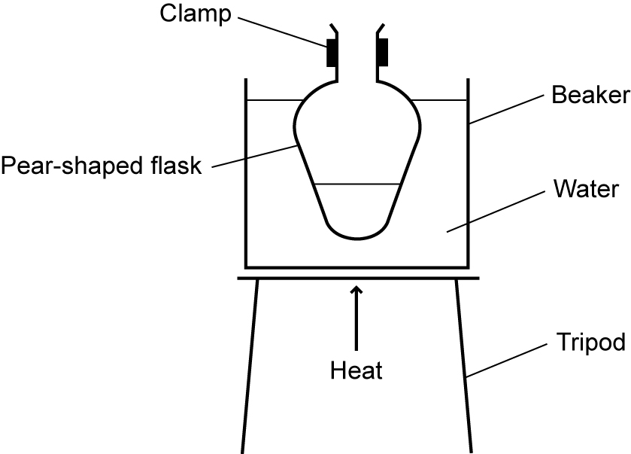

Questions
- Which functional group of the 2-hydroxybenzoic acid reacts with the ethanoic anhydride?
- Write an equation for the formation of aspirin from 2-hydroxybenzoic acid and use this to calculate the percentage yield.
- A sample of aspirin was analysed using infrared. State the absorptions you would expect to see and explain which bonds within the aspirin molecule are responsible for them.
- An NMR (hydrogen) spectrum was also obtained. There was one peak of relative intensity 1 at 11.2 ppm, four close peaks each of relative intensity 1 between 7.2 ppm and 8.1 ppm and a peak of relative intensity 3 at 2.3 ppm. Draw a molecule of aspirin and identify which of the protons were responsible for the peaks. (The four peaks at 7.2–8.1 can be considered together.)
- Would you expect to see any splitting patterns? Justify your answer.

