Student worksheet

Activity 10: Nylon rope trick and the preparation of a polyester resin and a polyacrylic ester
Objective
- Be able to prepare condensation polymers.
- Be able to prepare an addition polymer.

Equipment/materials
- 10 cm³ 1,6-diaminohexane solution (corrosive)
- 10 cm³ sebacoyl chloride (decanedioyl chloride) solution (corrosive)
- 3 g benzene-1,2-dicarboxylic acid anhydride (toxic)
- 2 cm³ propane-1,2,3-triol (low hazard)
- Perspex chips (low hazard)
- 0.1 g di(dodecanoyl) peroxide (oxidising)
- Two 100 cm³ beakers
- Small motor and suitable circuit
- Glass rod
- Forceps
- Two boiling tubes
- Delivery tube in a rubber bung (to fit boiling tube)
- Test tube
- Bunsen burner, safety mat, tripod and gauze
- Test tube holder
- Cotton wool
- Thermometer (reading to 300 °C)
- Top pan balance
- Three 10 cm³ measuring cylinders
- A clamp stand, two clamps and two bosses

Safety
- Perform the experiment in a well ventilated room
- Wear a lab coat, safety spectacles and nitrile disposable gloves, tie long hair back.

Corrosive Toxic
Oxidising
Procedure
A Nylon
- Put 10 cm³ of 1,6-diaminohexane solution into a small beaker.
- Carefully pour 10 cm³ of the sebacoyl chloride (decandioyl chloride) solution on top using a pipette.
- Using a pair of forceps pick up a thread from the interface between the two solutions.
- Slowly pull the thread and wrap it around the rod held in the motor. See Figure 10.
- Set the motor in motion and continue pulling the thread until no more is formed.

B A polyester resin
- Wearing protective gloves, mix 3 g of benzene-1,2-dicarboxylic acid anhydride with 2 cm³ of propane-1,2,3-triol in a boiling tube.
- Clamp the boiling tube and the thermometer. Heat slowly to 250 °C in a fume cupboard. Remove the thermometer. When the mixture stops bubbling allow it to cool. This takes no more than five minutes.
- Test the viscosity of your product.

C Polyacrylic ester
- Fill a boiling tube about one third full with small Perspex chips, place the stopper with delivery tube into the boiling tube. Clamp the boiling tube so that the open end of the delivery tube is in a small test tube in a beaker of cold water.
- Heat the boiling tube and collect the distillate.
- To 5 cm³ of the distillate add about 0.1 g of di(dodecanoyl) peroxide and shake the mixture until the catalyst has dissolved.
- Plug the test tube with cotton wool and place it in a beaker of water. Bring the water to the boil – the liquid should polymerise after about 10 minutes.

Analysis of results
- Record the appearance of each polymer.
- Write an equation for each reaction showing the repeat unit of each polymer.
- Classify each polymer as either a condensation or an addition polymer.

From the examiner
- Demonstrate skilful practical techniques.
- Observe all safety precautions and show awareness of all the hazards.
- Make and record valid observations.
Data/diagram
- Perspex is methyl -2-methylpropenoate
CH₂=C(CH₃)COOCH₃

Figure 10

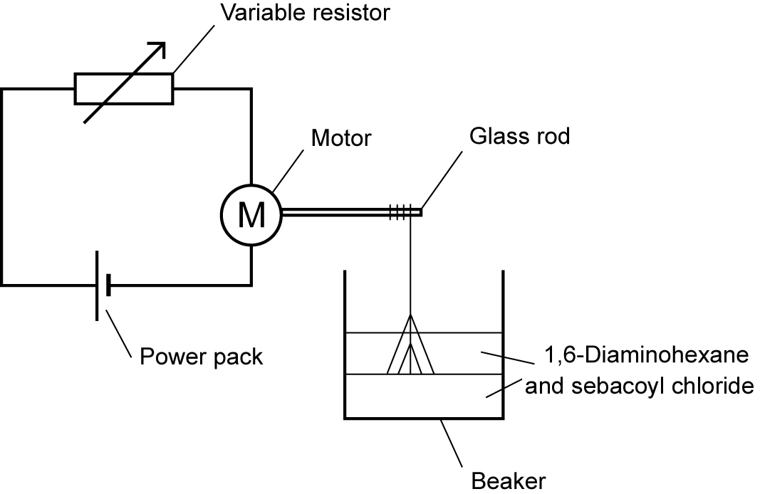
Questions
- The nylon produced is often called nylon 610 because the diaminohexane contains six carbon atoms and the (di)acyl chloride contains 10 carbon atoms. Give the formula of the (di)acyl chloride used to make nylon 66 and name the molecule.
- Draw a repeat unit of nylon 66.
- Nylon is a polyamide, show the linkage present in the polymer chain and state which naturally-occurring polymer has the same linkage.
- Industrially, benzene-1,4-dicarboxylic acid is reacted with ethane-1,2-diol. Draw a repeat unit of the product of this reaction and state what type of linkage is found in this polymer.
- Find two uses for the polymer produced in question 4.

