To Determine the Relative Molecular Mass of an Unknown Acid
Introduction

The purpose of this experiment is to carry out a titration to determine the relative molecular mass of an acid in order to confirm its identity.
You are provided with a solution of an unknown monoprotic acid (HA) and a solution of sodium hydroxide of concentration 0.100 mol dm⁻³.

You will be assessed on your ability to perform a titration carefully and accurately, and to analyse and evaluate your results.

Safety Notes
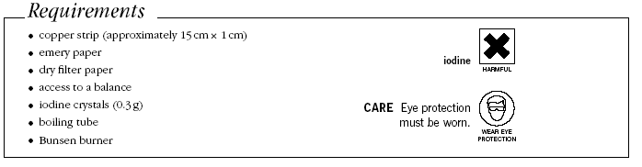
Irritant: unknown acid, sodium hydroxide

Method
The acid solution was prepared by weighing out 1.56 g of the acid using a two decimal place balance and then making up the solution in a 250 cm³ volumetric flask.
1. Wash all glassware with the appropriate solution before you start the titration.

2. Set up the burette and fill it with the acid solution.
3. Use a pipette to transfer 25.0cm³ of sodium hydroxide to a conical flask.
4. Add 3 or 4 drops of phenol red indicator to the conical flask
5. Carefully add the acid from the burette, swirling the flask frequently until the mixture just goes permanently orange. Use this as your rough titration.
6. Repeat the titration to obtain at least two concordant results. Make sure you add the acid drop-wise near the end-point and swirl the flask after each addition of acid.
7. Present your results in a suitable table, making sure you quote your readings to the appropriate degree of accuracy.
8. Use your results to calculate the mean titre, indicating which values you have used to calculate this value.
Results Table
- Record your results in the table below.
- Calculate your mean titre to one decimal place
 | Rough | Accurate
 | Rough | 1 | 2 | 3
Final burette reading /cm³
Initial burette reading /cm³
Titre / cm³

Analysis
1. a) Representing the acid as HA, write an equation between the acid and sodium hydroxide.

b) Calculate the amount in moles of NaOH in the 25.0 cm³ used in each titration.

c) Using the equation above, write down the amount in moles of HA in your mean titre.

d) Calculate the amount in moles of HA in 250 cm³ of the acid solution

e) Calculate the molar mass in g mol ⁻¹ of HA
Quote your answer to 3 significant figures

- Suggest a possible identity of the acid which is known to be one of the following:
Acid | Mr
HCl | 36.5
HNO₃ | 63
HBr | 81
CF₃COOH | 114
HI | 128
CCl₃COOH | 163.5

Evaluation
- Assume the apparatus errors are: pipette + 0.06 cm³, burette + 0.05 cm³
Calculate the % error in:
- the volume of NaOH in the pipette

- the mean titre

- Calculate the percentage difference between your calculated Mr and the Mr of the most likely acid. Comment on your answer.

