**Student Worksheet**

**Practical 7: Addition polymerisation – Making Poly(styrene)**

**Diagram**

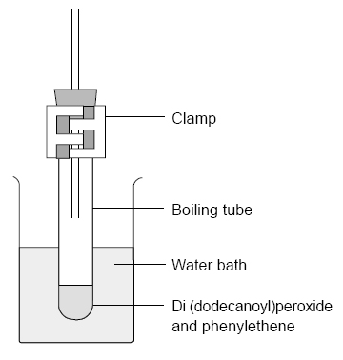

**Technicians notes:**

Pre-treatment of phenylethene: most phenylethene samples contain 4-(dimethylethyl)- benzene-1,2-diol, (4-tert-butyl catechol) (**Harmful**) as an inhibitor.

This needs to be removed by washing with 1 mol dm–3 sodium hydroxide solution (**Corrosive**), then with water, in a separating funnel. The phenylethene then needs to be dried over anhydrous sodium sulfate for 10 minutes.

Wash all the apparatus used in propanone (**Highly flammable**, **Irritant**) as soon as possible.

**Procedure**

1. Prepare a 250 cm3 beaker of boiling water to act as a water bath. If using a Bunsen burner, keep all other chemicals well away from the flame.
2. Add 0.1 g of di(dodecanoyl) peroxide to 5 cm3 of phenylethene in a boiling tube.
3. Fit a bung carrying a 20 cm length of glass tubing in the top of the boiling tube. This minimises the escape of phenylethene vapour.
4. Clamp the tube vertically in the boiling water bath so that the liquid in it is below the level of the hot water – see diagram.
5. Heat for about 30 min until the liquid turns quite viscous, remove from the water bath and leave to cool.
6. **Extinguish all flames.**
7. Pour the contents of the tube into 50 cm3 of ethanol in a beaker.
8. Use a glass rod to push the poly(phenylethene) into a lump and pour off the ethanol.
9. Dry the solid polymer on a filter paper.



Highly flammable



Harmful



Irritant

**Safety**

* Wear eye protection and gloves.
* Phenylethene is harmful and flammable.
* Di(dodecanoyl)peroxide is an irritant and oxidising.
* Ethanol is highly flammable and harmful

**Questions**

1. Draw a molecule of styrene.
2. Write a reaction showing the polymerisation of styrene

**Equipment/materials**

* Boiling tube
* Bung, one-holed, fitted with a 20 cm length of glass tubing (see diagram below)
* Plastic gloves
* Glass rod
* Clamp stand
* Bunsen burner, tripod, gauze and mat
* Phenylethene (styrene)
* Di(dodecanoyl)peroxide (lauroyl peroxide)
* Ethanol
* Filter paper

**Objective**

* Understand addition polymerisation.
* Work safely with flammable liquids